Avg build time: Time taken to build JAR/WAR/EAR file.

POL SCM: from Jenkins we are pinging to GIT server for checking any update.

GIT hooks: from GIT we are pinging to Jenkin server to say “Source code is updated”

Artifactory server: saving our build.

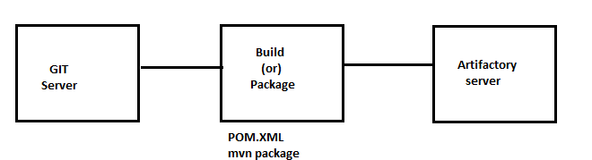

Antifactory server: It hold output for build purpose. It works as repository server.

Alternative for Artifactory: Cloud storage, SAN drive.

Note: Saving day build is optional, but we need to save night build.

Artifactory server URL: http//host:8081

Primary role of Artifactory server: WORA within project (or) network (or) Organisation.

Suppose you are running project with 3 teams- 1) Core team, 2) ExCom team and 3) Db team.

Suppose there is a work for AD implementation, and core team is responsible for it. Once core team develop product, they will put in antifactory server. And other two teams can use it as dependencies.

<dependencies> <dependency>

Default username password jfog repository: admin/password.

4EC- 4 Eye check.

SonarQube: This tool is used to check code quality.

public int div(int a, int b) { if(b==0) { Throw DivideByZeroException("Kindly pass non zero value") } return a/b; }

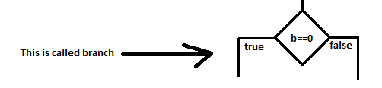

Quality gate:

line coverage:>90 // Number of lines are executed during code execution; this should be high.

branch coverage:>90 // branch coverage should be high.

symbol coverage:>90 // are we using variable that we have defined.

\*\*\* SonarQube is configured in every build